Folder Structure on the whole
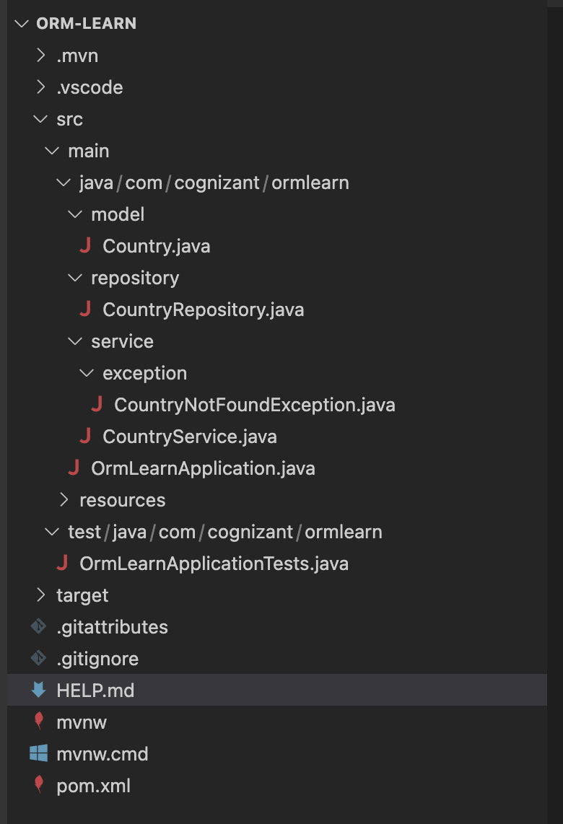

Hands-On 1: Spring Data JPA - Quick Example

Application.properties:

# Logging config
logging.level.org.springframework=info
logging.level.com.cognizant=debug
logging.level.org.hibernate.SQL=trace
logging.level.org.hibernate.type.descriptor.sql=trace

logging.pattern.console=%d{dd-MM-yy} %d{HH:mm:ss.SSS} %-20.20thread %5p %-25.25logger{25} %25M %4L %m%n

# Database config
spring.datasource.driver-class-name=com.mysql.cj.jdbc.Driver
spring.datasource.url=jdbc:mysql://localhost:3306/ormlearn
spring.datasource.username=root
spring.datasource.password=root

# Hibernate config
spring.jpa.hibernate.ddl-auto=validate
spring.jpa.properties.hibernate.dialect=org.hibernate.dialect.MySQL5Dialect

Country.java:
package com.cognizant.ormlearn.model;

import jakarta.persistence.Column;
import jakarta.persistence.Entity;
import jakarta.persistence.Id;
import jakarta.persistence.Table;
@Entity
@Table(name = "country")
public class Country {
@Id
@Column(name = "code")
private String code;
@Column(name = "name")
private String name;
public String getCode() {
return code;
}
public void setCode(String code) {
this.code = code;
}
public String getName() {
return name;
}
public void setName(String name) {
this.name = name;
}
@Override
public String toString() {
return "Country [code=" + code + ", name=" + name + "]";
}
}

CountryRepository.java
package com.cognizant.ormlearn.repository;

import org.springframework.data.jpa.repository.JpaRepository;
import org.springframework.stereotype.Repository;

import com.cognizant.ormlearn.model.Country;

@Repository
public interface CountryRepository extends JpaRepository<Country, String> {

}
CountryService.java:

package com.cognizant.ormlearn.service;
import java.util.List;
import org.springframework.beans.factory.annotation.Autowired;
import org.springframework.stereotype.Service;
import com.cognizant.ormlearn.model.Country;
import com.cognizant.ormlearn.repository.CountryRepository;
import jakarta.transaction.Transactional;
@Service
public class CountryService {

@Autowired
private CountryRepository countryRepository;

@Transactional
public List<Country> getAllCountries() {
return countryRepository.findAll();
}
}

OrmLearnApplication.java:

package com.cognizant.ormlearn;
import java.util.List;
import org.slf4j.Logger;
import org.slf4j.LoggerFactory;
import org.springframework.boot.SpringApplication;
import org.springframework.boot.autoconfigure.SpringBootApplication;
import org.springframework.context.ApplicationContext;
import com.cognizant.ormlearn.model.Country;
import com.cognizant.ormlearn.service.CountryService;
@SpringBootApplication
public class OrmLearnApplication {
private static final Logger LOGGER = LoggerFactory.getLogger(OrmLearnApplication.class);
private static CountryService countryService;
public static void main(String[] args) {
ApplicationContext context = SpringApplication.run(OrmLearnApplication.class, args);
LOGGER.info("Inside main");
countryService = context.getBean(CountryService.class);
testGetAllCountries();
}
private static void testGetAllCountries() {
LOGGER.info("Start");
List<Country> countries = countryService.getAllCountries();
LOGGER.debug("countries={}", countries);
LOGGER.info("End");
}
}

import.sql:
CREATE DATABASE ormlearn;
USE ormlearn;

CREATE TABLE country (
code VARCHAR(2) PRIMARY KEY,
name VARCHAR(50)
);
INSERT INTO country VALUES ('IN', 'India');
INSERT INTO country VALUES ('US', 'United States of America');

Output:
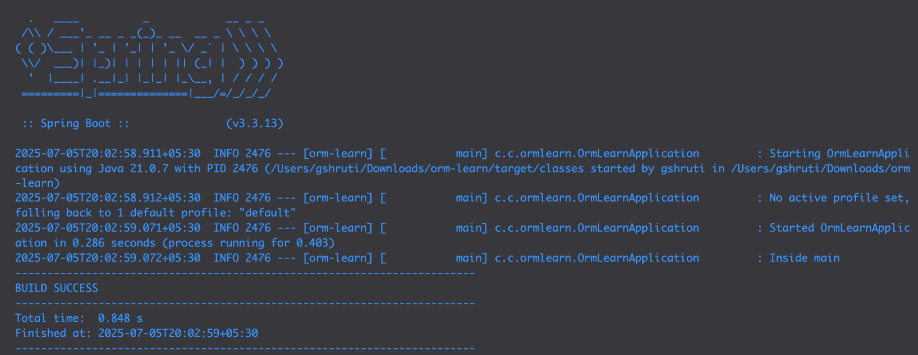

Hands-On 2: Hibernate XML Config implementation walk through

Object to Relational Mapping in XML
Hibernate uses mapping files (XML) to link Java classes and their properties to corresponding database tables and columns.
This XML mapping:
- Maps the Java class Country to the database table country
- Maps the field code to primary key column code
- Maps the field name to column name
Key Hibernate Concepts
- SessionFactory: A singleton, heavy-weight object created once per application. It reads the configuration file (hibernate.cfg.xml) and mapping files and creates sessions.
- Session: A lightweight, short-lived object used to interact with the database. Created by SessionFactory.
- Transaction: Optional but recommended. Represents a unit of work. Ensures atomicity.
Important API Methods
- beginTransaction(): Begins a database transaction.
- commit(): Commits changes made during the transaction to the DB.
- rollback(): Rolls back the changes in case of failure/error.
- session.save(obj): Saves a new entity to the db, Returns the identifier.
- session.get(Class,id): Fetches an entity by primary key. Return null if not found.
- session.createQuery().list(): Executes HQL query and returns list of results.
- session.delete(obj): deletes the specified entity from the db.
File Structure in XML Config Setup
- hibernate.cfg.xml: Central configuration file with db details, mappings.
- *.hbm.xml: Mapping file which maps Java class to db.
- Java POJO: Class with fields, getters, setters.
- HibernateUtil.java: Utility to create and manage SessionFactory.
Sample Hibernate Configuration (hibernate.cfg.xml):
<hibernate-configuration>
<session-factory>
<property name="hibernate.connection.driver_class">com.mysql.cj.jdbc.Driver</property>
<property name="hibernate.connection.url">jdbc:mysql://localhost:3306/ormlearn</property>
<property name="hibernate.connection.username">root</property>
<property name="hibernate.connection.password">root</property> <property name="hibernate.dialect">org.hibernate.dialect.MySQL5Dialect</property>
<mapping resource="Country.hbm.xml"/>
</session-factory>
</hibernate-configuration

Hands-on 3: Hibernate Annotation Configuration Walkthrough

Object to Relational Mapping Using Annotations:

Hibernate allows you to map Java classes to database tables using annotations.
Example:
import jakarta.persistence.*;
@Entity
@Table(name = "employee")
public class Employee {
@Id
@GeneratedValue(strategy = GenerationType.IDENTITY)
@Column(name = "id")
private int id;
@Column(name = "first_name")
private String firstName;
@Column(name = "last_name")
private String lastName;
@Column(name = "salary")
private int salary;
}

Annotations Explained (Point Format)
- @Entity
→ Marks the class as a Hibernate entity.
- @Table(name = "employee")
→ Maps the class to the database table named employee.
- @Id
→ Specifies the primary key field of the entity.
- @GeneratedValue(strategy = GenerationType.IDENTITY)
→ Defines how the primary key is auto-generated.
→ IDENTITY strategy uses the database's auto-increment feature.
- @Column(name = "...")
→ Maps a class field to a specific column name in the table.
Hibernate CRUD Operations in Code
SessionFactory factory = new Configuration().configure("hibernate.cfg.xml")
.addAnnotatedClass(Employee.class)
.buildSessionFactory();
Session session = factory.getCurrentSession();
try {
Employee emp = new Employee("Shruti", "G", 30000);
session.beginTransaction();
session.save(emp);
session.getTransaction().commit();
} finally {
factory.close();
}

Hands-on 4: Difference between JPA, Hibernate, and Spring Data JPA
Java Persistence API (JPA)
- JPA is a Java specification (JSR 338) for persisting, reading, and managing data from Java objects.
- It is only an interface/contract, not a concrete implementation.
- It defines standard annotations like @Entity, @Id, @Table, etc.
- Examples of implementations: Hibernate, EclipseLink, DataNucleus.
Hibernate
- Hibernate is an ORM (Object Relational Mapping) tool.
- It is the most popular implementation of JPA.
- Provides extra features over JPA like:
  - Lazy/eager fetching strategies
  - Caching support
  - Better query language (HQL)
- Can be used both with or without JPA.
Spring Data JPA
- Not a JPA implementation.
- It's a part of the Spring ecosystem that provides:
  - A higher level abstraction over JPA.
  - Built-in support for common CRUD operations.
  - Reduces boilerplate code via interfaces like JpaRepository.
- Internally uses JPA implementations like Hibernate.
- Handles:
  - Repository pattern
  - Transaction management
  - Pagination, sorting, and query derivation by method names.
Comparison: Hibernate vs Spring Data JPA
Hibernate (Manual Session Management):
public Integer addEmployee(Employee employee) {
Session session = factory.openSession();
Transaction tx = null;
Integer employeeID = null;
try {
tx = session.beginTransaction();
employeeID = (Integer) session.save(employee);
tx.commit();
} catch (HibernateException e) {
if (tx != null) tx.rollback();
e.printStackTrace();
} finally {
session.close();
}
return employeeID;
}

Spring Data JPA (Simplified)
@Service
public class EmployeeService {
@Autowired
private EmployeeRepository employeeRepository;
@Transactional
public void addEmployee(Employee employee) {
employeeRepository.save(employee);
}
}

Hands-on 5: Implement Services for Managing Country
CountryService.java:
package com.cognizant.ormlearn.service;
import com.cognizant.ormlearn.model.Country;
import com.cognizant.ormlearn.repository.CountryRepository;
import jakarta.transaction.Transactional;
import org.springframework.beans.factory.annotation.Autowired;
import org.springframework.stereotype.Service;
import java.util.List;
import java.util.Optional;
@Service
public class CountryService {
@Autowired
private CountryRepository countryRepository;
@Transactional
public List<Country> getAllCountries() {
return countryRepository.findAll();
}
@Transactional
public Country findCountryByCode(String code) {
Optional<Country> result = countryRepository.findById(code);
return result.orElse(null);
}
@Transactional
public void addCountry(Country country) {
countryRepository.save(country);
}

@Transactional
public void updateCountry(String code, String name) {
Country country = findCountryByCode(code);
if (country != null) {
country.setName(name);
countryRepository.save(country);
}
}
@Transactional
public void deleteCountry(String code) {
countryRepository.deleteById(code);
}
@Transactional
public List<Country> findCountriesByName(String name) {
return countryRepository.findByNameContainingIgnoreCase(name);
}
}
CountryRepositrory.java:
package com.cognizant.ormlearn.repository;
import com.cognizant.ormlearn.model.Country;
import org.springframework.data.jpa.repository.JpaRepository;
import org.springframework.stereotype.Repository;
import java.util.List;
@Repository
public interface CountryRepository extends JpaRepository<Country, String> {
List<Country> findByNameContainingIgnoreCase(String name);
}

OrmLearnApplication.java:
package com.cognizant.ormlearn;
import com.cognizant.ormlearn.model.Country;
import com.cognizant.ormlearn.service.CountryService;
import org.slf4j.Logger;
import org.slf4j.LoggerFactory;
import org.springframework.boot.SpringApplication;
import org.springframework.boot.autoconfigure.SpringBootApplication;
import org.springframework.context.ApplicationContext;
import java.util.List;
@SpringBootApplication
public class OrmLearnApplication {
private static CountryService countryService;
private static final Logger LOGGER = LoggerFactory.getLogger(OrmLearnApplication.class);
public static void main(String[] args) {
ApplicationContext context = SpringApplication.run(OrmLearnApplication.class, args);
countryService = context.getBean(CountryService.class);
LOGGER.info("Inside main");
testAddCountry();
testGetAllCountries();
testFindCountryByCode();
testUpdateCountry();
testDeleteCountry();
testFindCountriesByName();
}
private static void testGetAllCountries() {
LOGGER.info("Start");
List<Country> countries = countryService.getAllCountries();
LOGGER.debug("Countries = {}", countries);
LOGGER.info("End");
}
private static void testFindCountryByCode() {
LOGGER.info("Start");
Country country = countryService.findCountryByCode("IN");
LOGGER.debug("Country = {}", country);
LOGGER.info("End");
}
private static void testAddCountry() {
LOGGER.info("Start");
Country country = new Country();
country.setCode("XY");
country.setName("NewTestCountry");
countryService.addCountry(country);
LOGGER.info(" New Country added: {}", countryService.findCountryByCode("XY"));
}
private static void testUpdateCountry() {
LOGGER.info("Start");
countryService.updateCountry("XY", "UpdatedCountryName");
LOGGER.info(" Country updated: {}", countryService.findCountryByCode("XY"));
}
private static void testDeleteCountry() {
LOGGER.info("Start");
countryService.deleteCountry("XY");
LOGGER.info(" Country deleted.");
}

private static void testFindCountriesByName() {
LOGGER.info("Start");
List<Country> countries = countryService.findCountriesByName("an");
LOGGER.debug("Countries with 'an' in name: {}", countries);
LOGGER.info("End");
}
}

Country.java:
package com.cognizant.ormlearn.model;
import jakarta.persistence.Column;
import jakarta.persistence.Entity;
import jakarta.persistence.Id;
import jakarta.persistence.Table;
@Entity
@Table(name = "country")
public class Country {
@Id
@Column(name = "co_code")
private String code;

@Column(name = "co_name")
private String name;
public String getCode() {
return code;
}
public void setCode(String code) {
this.code = code;
}
public String getName() {
return name;
}
public void setName(String name) {
this.name = name;
}
@Override
public String toString() {
return "Country [code=" + code + ", name=" + name + "]";
}
}

Output:
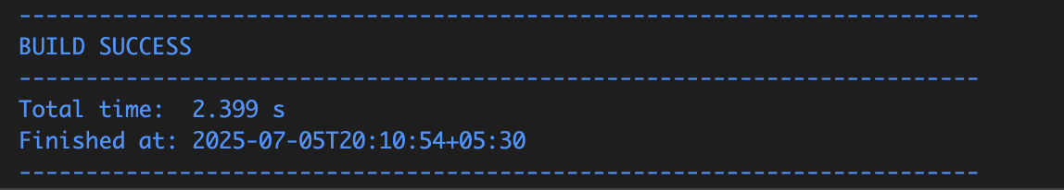

Hands-on 6: Find a Country Based on Country Code
CountryNotFoundException.java:
package com.cognizant.ormlearn.service.exception;
public class CountryNotFoundException extends Exception {
public CountryNotFoundException(String message) {
super(message);
}
}
CountryService.java:
package com.cognizant.ormlearn.service;
import com.cognizant.ormlearn.model.Country;
import com.cognizant.ormlearn.repository.CountryRepository;
import com.cognizant.ormlearn.service.exception.CountryNotFoundException;
import jakarta.transaction.Transactional;
import org.springframework.beans.factory.annotation.Autowired;
import org.springframework.stereotype.Service;
import java.util.List;
import java.util.Optional;
@Service
public class CountryService {
@Autowired
private CountryRepository countryRepository;
@Transactional
public List<Country> getAllCountries() {
return countryRepository.findAll();
}
@Transactional
public Country findCountryByCode(String countryCode) throws CountryNotFoundException {
Optional<Country> result = countryRepository.findById(countryCode);
if (!result.isPresent()) {
throw new CountryNotFoundException("Country not found for code: " + countryCode);
}
return result.get();
}
}

OrmLearnApplication.java:
Added this method to already present code
private static void testFindCountryByCodeException() {
LOGGER.info("Start");
try {
Country country = countryService.findCountryByCode("IN");
LOGGER.debug("Country: {}", country);
} catch (Exception e) {
LOGGER.error("Exception: {}", e.getMessage());
}
LOGGER.info("End");
}

Add this to the main method
testFindCountryByCodeException();

Output:
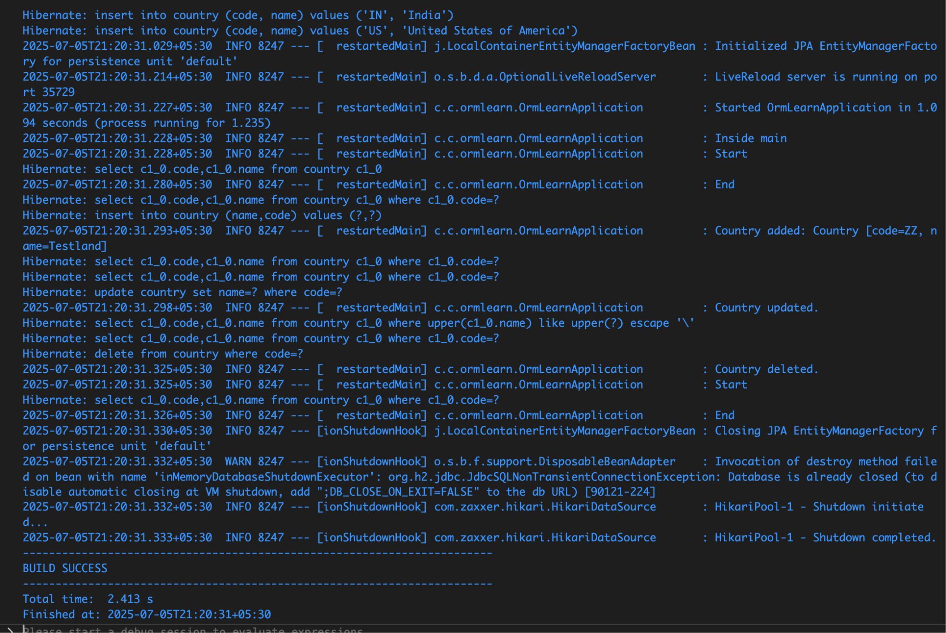
Hands-on 7: Add a New Country
CountryService.java:
Update the code already present by adding
@Transactional
public void addCountry(Country country) {
countryRepository.save(country);
}

OrmLearnApplication:
Update the already present code by adding this method
private static void testAddCountry() {
LOGGER.info("Start");
Country country = new Country();
country.setCode("ZZ");
country.setName("Testland");
countryService.addCountry(country);
try {
Country savedCountry = countryService.findCountryByCode("ZZ");
LOGGER.debug("Added Country: {}", savedCountry);
} catch (Exception e) {
LOGGER.error("Country not found after adding: {}", e.getMessage());
}
LOGGER.info("End");
}

Also adding this to the main method
public static void main(String[] args) {
ApplicationContext context = SpringApplication.run(OrmLearnApplication.class, args);
countryService = context.getBean(CountryService.class);
testAddCountry(); }
Hands-On 8: Update a country based on code
CountryService.java:
Update the code already present by adding
@Transactional
public void updateCountry(String code, String name) {
Optional<Country> result = countryRepository.findById(code);
if (result.isPresent()) {
Country country = result.get();
country.setName(name);
countryRepository.save(country);
} else {
throw new RuntimeException("Country with code " + code + " not found");
}
}

OrmLearnApplication:
Update the already present code by adding this method
private static void testUpdateCountry() {
LOGGER.info("Start");
countryService.updateCountry("IN", "Bharat");
try {
Country updatedCountry = countryService.findCountryByCode("IN");
LOGGER.debug("Updated Country: {}", updatedCountry);
} catch (Exception e) {
LOGGER.error("Country not found: {}", e.getMessage());
}
LOGGER.info("End");
}

Also adding this to the main method
public static void main(String[] args) {
ApplicationContext context = SpringApplication.run(OrmLearnApplication.class, args);
countryService = context.getBean(CountryService.class);
testUpdateCountry();
}

Output:
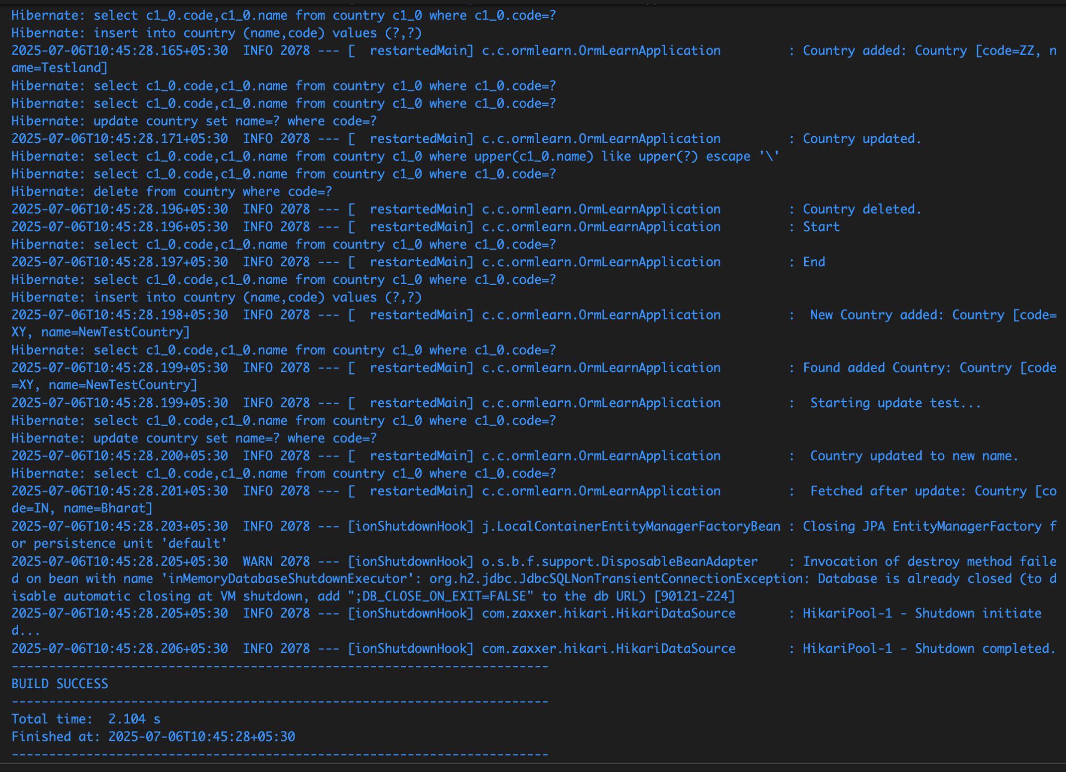

Hands-on 8: Update a Country Based on Code
CountryService.java:
Update the code already present by adding
@Transactional
public void updateCountry(String code, String name) {
Optional<Country> result = countryRepository.findById(code);
if (result.isPresent()) {
Country country = result.get();
country.setName(name);
countryRepository.save(country);
} else {
throw new RuntimeException("Country with code " + code + " not found");
}
}

OrmLearnApplication:
Update the already present code by adding this method
private static void testUpdateCountry() {
LOGGER.info("Start");
countryService.updateCountry("IN", "Bharat");
try {
Country updatedCountry = countryService.findCountryByCode("IN");
LOGGER.debug("Updated Country: {}", updatedCountry);
} catch (Exception e) {
LOGGER.error("Country not found: {}", e.getMessage());
}
LOGGER.info("End");
}

Also adding this to the main method
public static void main(String[] args) {
ApplicationContext context = SpringApplication.run(OrmLearnApplication.class, args);
countryService = context.getBean(CountryService.class);

testUpdateCountry();
}

Output:


Hands-on 9: Delete a Country Based on Code
CountryService.java:
package com.cognizant.ormlearn.service;
import java.util.List;
import java.util.Optional;
import org.springframework.beans.factory.annotation.Autowired;
import org.springframework.stereotype.Service;
import com.cognizant.ormlearn.model.Country;
import com.cognizant.ormlearn.repository.CountryRepository;
import com.cognizant.ormlearn.service.exception.CountryNotFoundException;
import jakarta.transaction.Transactional;
@Service
public class CountryService {
@Autowired
private CountryRepository countryRepository;
public List<Country> getAllCountries() {
return countryRepository.findAll();
}
@Transactional
public Country findCountryByCode(String countryCode) throws CountryNotFoundException {
Optional<Country> result = countryRepository.findById(countryCode);
if (!result.isPresent()) {
throw new CountryNotFoundException("Country with code " + countryCode + " not found");
}
return result.get();
}
@Transactional
public void addCountry(Country country) {
countryRepository.save(country);
}
@Transactional
public void updateCountry(String code, String name) throws CountryNotFoundException {
Optional<Country> optionalCountry = countryRepository.findById(code);
if (!optionalCountry.isPresent()) {
throw new CountryNotFoundException("Country with code " + code + " not found");
}
Country country = optionalCountry.get();
country.setName(name);
countryRepository.save(country);
}
@Transactional
public void deleteCountry(String code) throws CountryNotFoundException {
Optional<Country> optionalCountry = countryRepository.findById(code);
if (!optionalCountry.isPresent()) {
throw new CountryNotFoundException("Country with code " + code + " not found");
}
countryRepository.deleteById(code);
}
public List<Country> searchCountriesByPartialName(String name) {
return countryRepository.findByNameContainingIgnoreCase(name);
}
}
OrmLearnApplication.java:
package com.cognizant.ormlearn;
import java.util.List;
import org.slf4j.Logger;
import org.slf4j.LoggerFactory;
import org.springframework.boot.SpringApplication;
import org.springframework.boot.autoconfigure.SpringBootApplication;
import org.springframework.context.ApplicationContext;
import com.cognizant.ormlearn.model.Country;
import com.cognizant.ormlearn.service.CountryService;
import com.cognizant.ormlearn.service.exception.CountryNotFoundException;
@SpringBootApplication
public class OrmLearnApplication {
private static final Logger LOGGER = LoggerFactory.getLogger(OrmLearnApplication.class);
private static CountryService countryService;
public static void main(String[] args) {
ApplicationContext context = SpringApplication.run(OrmLearnApplication.class, args);
LOGGER.info("Inside main");
countryService = context.getBean(CountryService.class);
testGetAllCountries();
testAddCountry();
testFindCountryByCode("ZZ");
testUpdateCountry();
testSearchCountriesByName("land");
testDeleteCountry();
testFindCountryByCodeIndia();
testAddCountryNew();
testUpdateCountryNew();
testDeleteAddedCountry();
}
private static void testGetAllCountries() {
LOGGER.info("Start");
List<Country> countries = countryService.getAllCountries();
LOGGER.debug("All countries: {}", countries);
LOGGER.info("End");`}
private static void testFindCountryByCode(String code) {
try {
Country country = countryService.findCountryByCode(code);
LOGGER.debug("Country: {}", country);
} catch (CountryNotFoundException e) {
LOGGER.error("Error: {}", e.getMessage());
}
}
private static void testAddCountry() {
Country newCountry = new Country();
newCountry.setCode("ZZ");
newCountry.setName("Testland");
countryService.addCountry(newCountry);
LOGGER.info("Country added: {}", newCountry);
}
private static void testUpdateCountry() {
try {
countryService.updateCountry("ZZ", "Updated Testland");
LOGGER.info("Country updated.");
} catch (CountryNotFoundException e) {
LOGGER.error("Error updating country: {}", e.getMessage());
}
}
private static void testDeleteCountry() {
try {
countryService.deleteCountry("ZZ");
LOGGER.info("Country deleted.");
} catch (CountryNotFoundException e) {
LOGGER.error("Error deleting country: {}", e.getMessage());}
}
private static void testSearchCountriesByName(String keyword) {
List<Country> results = countryService.searchCountriesByPartialName(keyword);
LOGGER.debug("Search results for '{}': {}", keyword, results);
}
private static void testFindCountryByCodeIndia() {
try {
LOGGER.info("Start");
Country country = countryService.findCountryByCode("IN");
LOGGER.debug("Country: {}", country);
LOGGER.info("End");
} catch (CountryNotFoundException e) {
LOGGER.error("Exception: {}", e.getMessage());
}
}
private static void testAddCountryNew() {
Country newCountry = new Country();
newCountry.setCode("XY");
newCountry.setName("NewTestCountry");
countryService.addCountry(newCountry);
LOGGER.info(" New Country added: {}", newCountry);
try {
Country foundCountry = countryService.findCountryByCode("XY");
LOGGER.info("Found added Country: {}", foundCountry);
} catch (CountryNotFoundException e) {
LOGGER.error(" Country not found after add: {}", e.getMessage());
}
}
private static void testDeleteAddedCountry() {
try {
LOGGER.info(" Deleting test country 'XY'...");
countryService.deleteCountry("XY");
LOGGER.info(" Country 'XY' deleted.");
try {
countryService.findCountryByCode("XY");
} catch (CountryNotFoundException e) {
LOGGER.info(" Confirmed: Country 'XY' no longer exists.");
}
} catch (CountryNotFoundException e) {
LOGGER.error(" Error deleting country: {}", e.getMessage());
}
}
private static void testUpdateCountryNew() {
try {
LOGGER.info(" Starting update test...");
countryService.updateCountry("IN", "Bharat");
LOGGER.info(" Country updated to new name.");
Country updated = countryService.findCountryByCode("IN");
LOGGER.info(" Fetched after update: {}", updated);
} catch (CountryNotFoundException e) {
LOGGER.error("Error updating country: {}", e.getMessage());
}
}
}
Output:
